PUBLIC INFORMATION AND EDUCATION
2018 Highlights
The Cherry Creek Basin Water Quality Authority is identified as the designated water quality management agency for the Cherry Creek watershed. The Cherry Creek Stewardship Partners were founded in 1998 as a forum for the active stewardship of the Cherry Creek Watershed both above and below the Cherry Creek Dam. By compiling the education and outreach priorities of other local agencies and districts in the watershed the Cherry Creek Stewardship Partners created the Cherry Creek Basin Stewardship and Education Initiative. This document served as a needs assessment and provided a set of recommendations for future efforts to engage the public with informational and educational programs in addition to the stormwater requirements in section 72.7. The Cherry Creek Basin Water Quality Authority continues to provide significant funding and expertise helping the Partners to accomplish public education and participation goals.
In addition to providing tours and events that remind watershed residents of their ability to reduce pollution from sources that could be mobilized during storm events, the Partners promote awareness of the value and function of the many pollution abatement projects that have been constructed in the Cherry Creek Basin with funding from the Cherry Creek Basin Water Quality Authority and their valuable partners: Urban Drainage and Flood Control District, Arapahoe and Douglas County Open Space Programs, the Cities and Towns of Aurora, Castle Rock, Centennial, Denver, Lone Tree, Parker, Parker Jordan Metropolitan District, Colorado State Parks and Great Outdoors Colorado.

We have chosen the Denver Regional Science and Engineering Fair as one important opportunity to engage students and their teachers in watershed stewardship. By promoting better understanding of the purpose and effect of public works and water quality programs more young people gain awareness of the challenges of protecting public health and the environment.
Cherry Creek Stewardship Partners Educator Deva DeAngelis-Lowe presents Shreyas Sriram, an 8th Grader at Challenge School in the Cherry Creek District, with the 2018 Cherry Creek Basin Water Quality Authority’s award in recognition of excellence and outstanding achievements in Environmental Science for his project: Using Artificial Intelligence And Raspberry Pi To Monitor And Conserve Household Water Usage

Honoring the history and culture of the Cherry Creek watershed, the Partners collaborate with iconic open space properties in the Cherry Creek Watershed, Cherry Creek State Park, Arapahoe County’s 17-Mile House Farm Park and Douglas County’s Prairie Canyon Ranch.
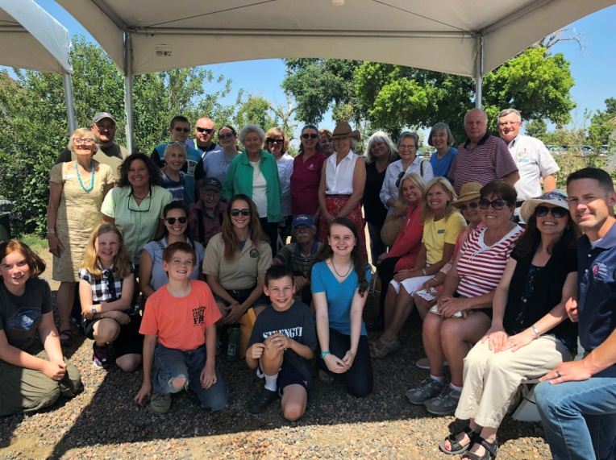
The 17-Mile House Farm Park is a prominent open space park owned and managed by the people of Arapahoe County by their support of the Arapahoe County Open Space Tax. The Park is also host to the annual Fall Festival which brings thousands of local residents in touch with their farming heritage. The Park has monthly open-house events with tours of the house and bar providing unique opportunities to engage the interested public to provide valuable information relating to land use, water quality and watershed stewardship.
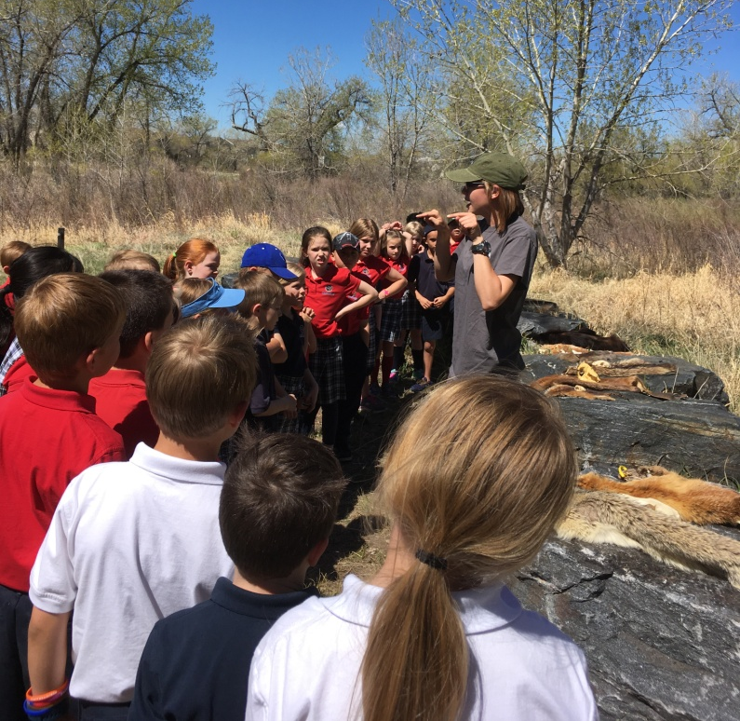
In 2018 the Partners hosted 1,150 school age students and their parents to explore the cultural and natural history as seen through the lens of an 1860’s era farm at the 17-Mile House Farm Park. Here students are invited to explore their ‘inner wildlife’ as they explore the landscape and practice their outdoor observation and play skills. We believe you are never too young, or too old, to learn about stormwater, flood protection and the value of our natural resource heritage.
Programming at the 17-Mile House Farm Park is a valuable collaboration among Arapahoe County Open Space, Cherry Creek Valley Historical Society Cherry Creek State Park and the Cherry Creek Stewardship Partners.
Over 400 West Middle School 6th Graders enjoyed two days of ‘Water Festival’ at Cherry Creek State Park in May of 2018. Eight stations staffed by Partners’ volunteers provided hands on water science experiences ranging from dam design and function to water chemistry and physics.
With broad support from local jurisdictions and the Cherry Creek Basin Water Quality Authority, the Partners bring students of all ages and area residents out to the Creek to learn the history and ecology of the Cherry Creek watershed. Events and outings are posted on their website: www.cherry-creek.org You are invited to join the Partners on any of their excursions. Come on out to the Creek!
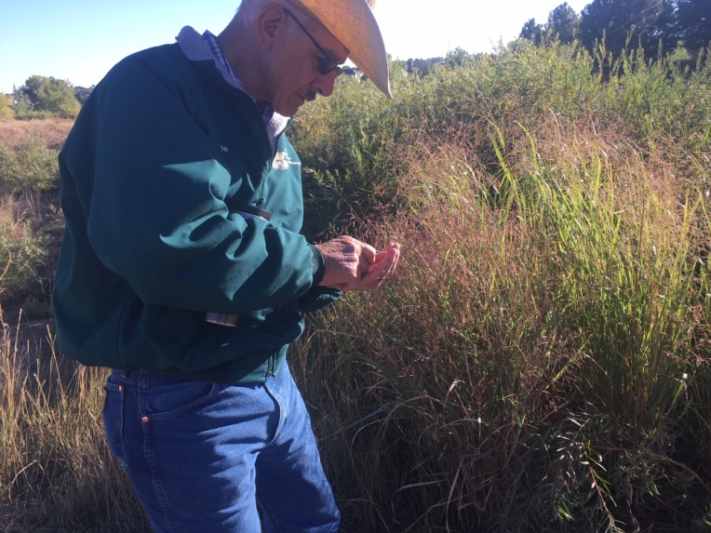
Don Hijar, regional expert on native grasses, forbs and shrubs joins the Partners’ Fall Equinox Walk at Cherry Creek Valley Ecological Park hosted with support from the Cherry Creek Basin Water Quality Authority, Southeast Metro Stormwater Authority, Stormwater Permittees for Local Awareness of Stream Health (SPLASH), Parker Jordan Metropolitan District and the City of Centennial.
Looking to the upper reaches of the Cherry Creek watershed (and our sister watersheds) we find opportunities to engage with agriculture and silviculture practices, individual sewage disposal systems, large lot development greater than one acre (from an agricultural perspective considered small acreage landownership), and other potential nutrient sources. Working with Douglas and Kiowa Conservation Districts, Colorado State University Extension Services, Master Gardeners and Douglas County Open Space the Partners provide educational tours and workshops such as the 2018 Grass Tour and the Technical Advisory Committee meeting at Prairie Canyon Ranch.

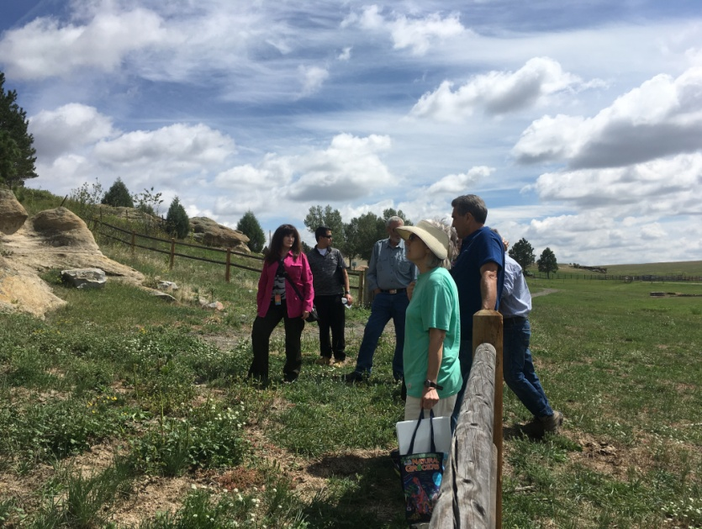

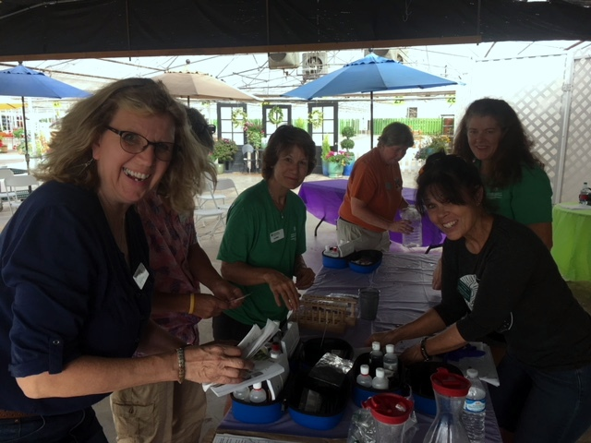
Master Gardeners with the Colorado State University Extension Service help local gardeners understand the chemistry of their yard and garden soil at the annual ‘Fall Into Fertilizer’ event presented with the generous support of the Cherry Creek Basin Water Quality Authority and Tagawa Garden Center and Nursery in Centennial, Colorado. Proper application of fertilizers is essential to protecting water quality in the Cherry Creek watershed.
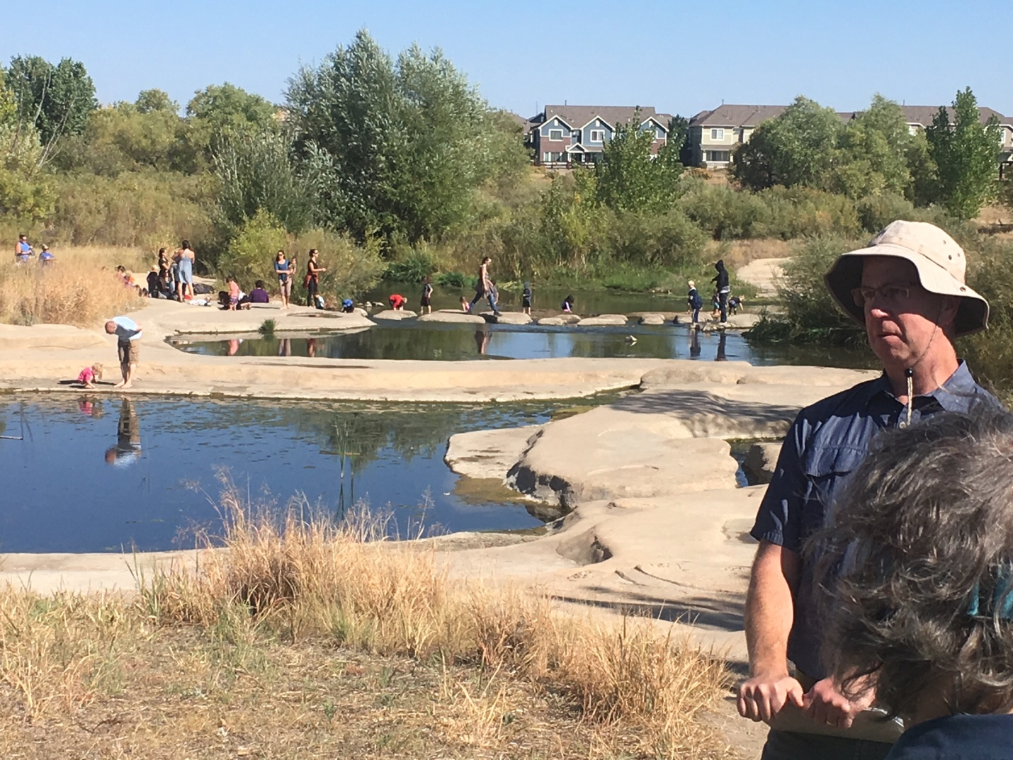

Rich Borchardt, P.E. with R2R Engineers and one of the leaders on Phase 2 of the Cherry Creek Valley Ecological Park stream reclamation and pollution abatement project spoke to managers from EPA Region 8’s Office of Water Protection for a tour of local efforts to address phosphorus and other pollution and to better manage stormwater. The tour was sponsored with support from Cherry Creek Basin Water Quality Authority, Southeast Metro Stormwater Authority and the Town of Parker.

In November of every year the Cherry Creek Basin Water Quality Authority is co-sponsor of the annual Cherry Creek Watershed Conference. In 2018 the Conference was held at the University of Colorado South Campus with over 125 local water quality professionals, engineers and practitioners gathering to review the year’s accomplishments, learn from each other and acknowledge the significant contributions of the public and private interests that contribute to long term stewardship of the Cherry Creek Watershed.

Lanae Raymond, recipient of the 2018 Marie MacKenzie Legacy Award, is congratulated by Bill Ruzzo, recipient of the 2012 Marie MacKenzie Legacy Award. Bill and Lanae are icons for stewardship in the Cherry Creek watershed and are the only two people to have been honored with this prestigious award established by the Cherry Creek Stewardship Partners to pay tribute to former Arapahoe County Commissioner, Marie MacKenzie, who strengthened our mission, increased awareness about the natural resources in the basin, demonstrated leadership and outstanding community service, and provided an enduring legacy that established Cherry Creek as a premier natural area to be protected, enhanced, and preserved. With this award, her smile and spirit will be remembered each time it is bestowed.

